**FEAR OF LOVE**

**Logline :**

**Characters :**

**Justin :**



A teen age boy who has immense knowledge on music and instruments and can control sound waves , travels in the speed of sound and can attack with the help of musical notes.

**Pavan (Hero ) :**

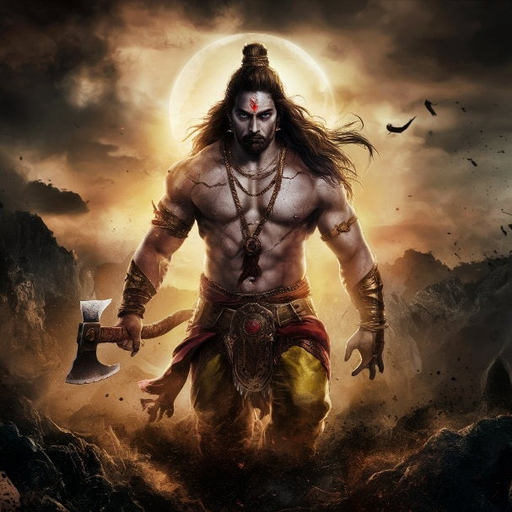

**Subhashini (Heroine) :**

**Vibhu Radheya :**

An old man who has control over sky , water , fire , earth , air and has immense knowledge .Has been involved in many of the wars and knows the value of each life , as he’s seen many people die . Now trying to gain peace without any disputes and leading a simple life. He decides not to involve in any kind of wars unless its mandatory and stays in a secret place meditating.

**Dhananjaya :**

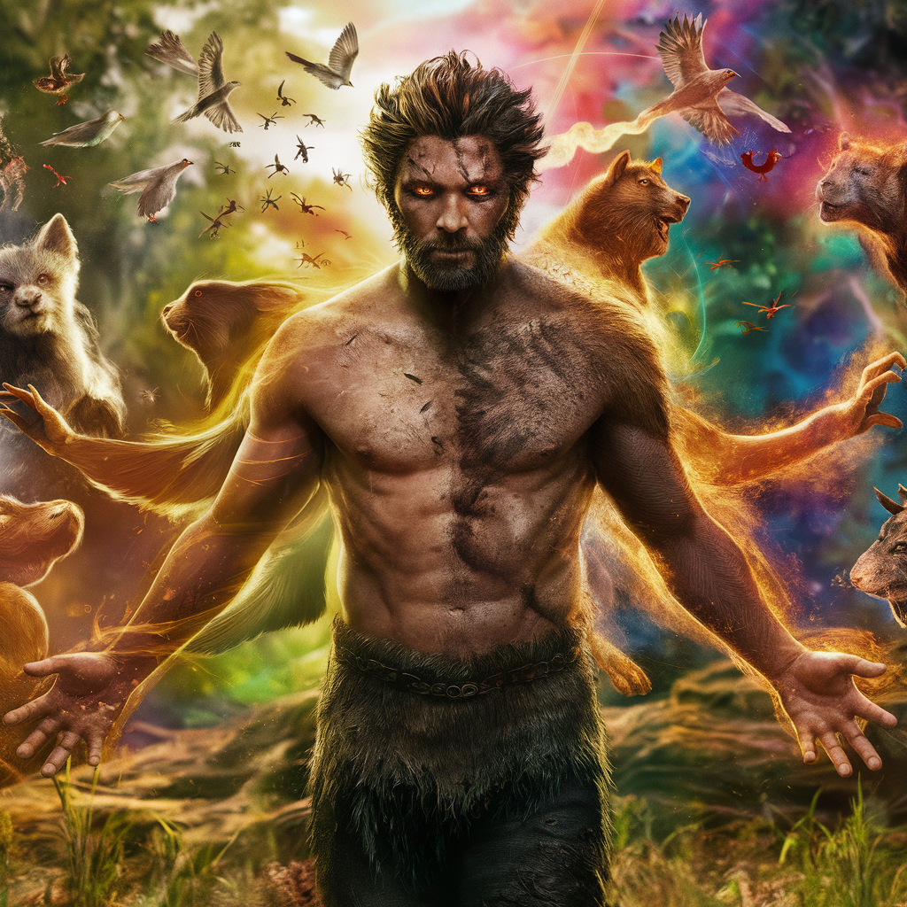 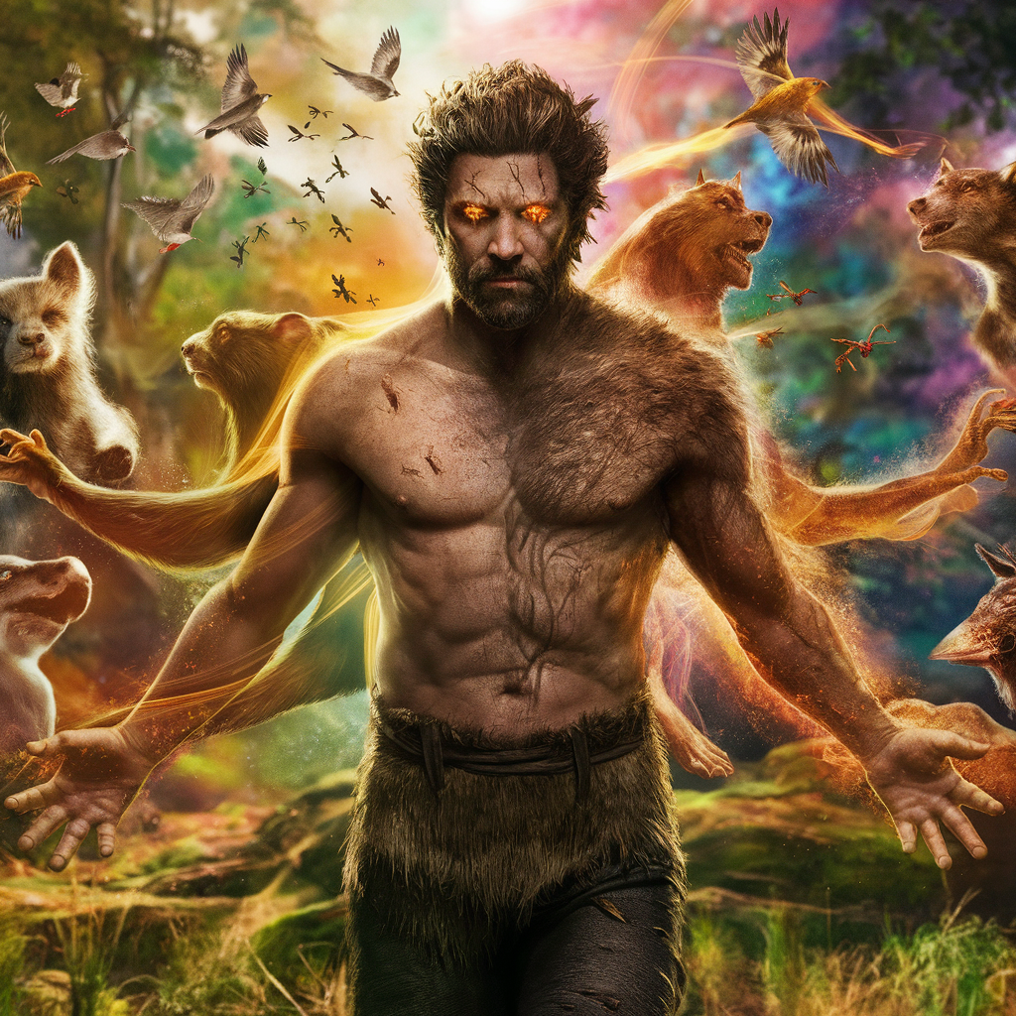

A lost boy in the forest grown by the tribes, gets the unique powers by mastering all of them with the help of the tribes . Man with a wild, raw, and rustic appearance, standing in the midst of a lush forest. He has the ability to control and communicate with animals, birds, insects, and trees. His eyes glow with an otherworldly energy as he transforms into various animal forms, showcasing his incredible shape-shifting prowess.

**Devavratha (Antagonist 1):**

**Monika :**